**CSP 554 – Assignment #11**

Name: Adarsh Mathad Vijayakumar

CWID: A20424847

Email ID: avijayakumar@hawk.iit.edu

Exercise 1)

Create an HBase table with the following characteristics

Table Name: csp554Tbl

First column family: cf1

Second column family: cf2

Then execute the DESCRIBE command on the table and return command you wrote and the output as the results of this exercise.

Commands:

create 'csp554Tbl','cf1','cf2'

describe 'csp554Tbl'

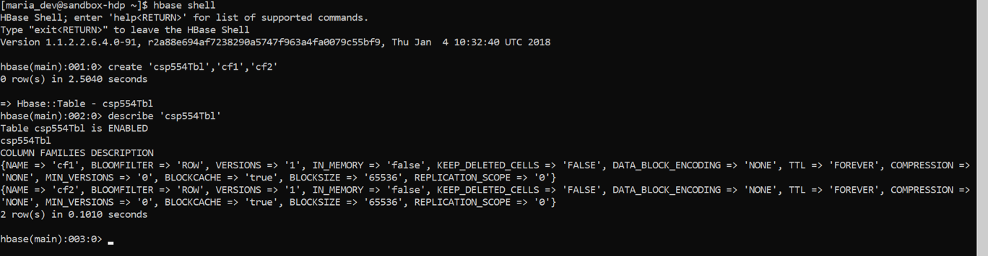

Exercise 2)

Put the data into the table created in exercise 1.

Execute the SCAN command on this table returning all rows, column families and columns as the result of the exercise.

Commands:

put 'csp554Tbl','1','cf1:name','Sam'

put 'csp554Tbl','2','cf1:name','Ahmed'

put 'csp554Tbl','1','cf2:job','Pilot'

put 'csp554Tbl','2','cf2:job','Doctor'

put 'csp554Tbl','1','cf2:level','LZ3'

put 'csp554Tbl','2','cf2:level','AR7'

scan 'csp554Tbl'

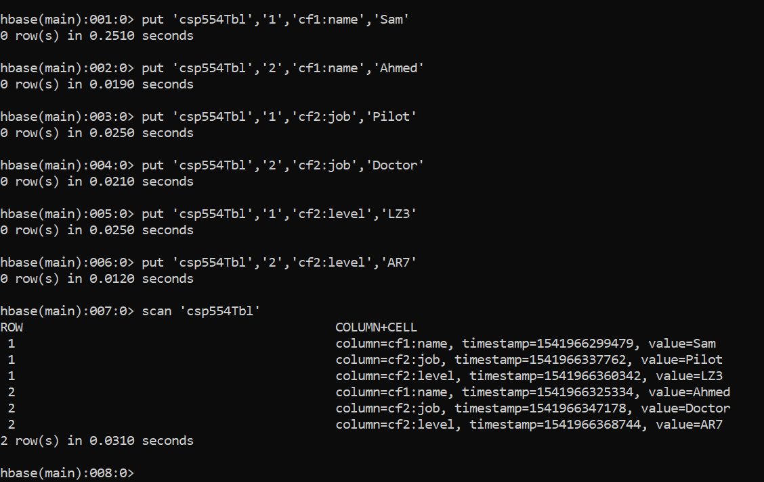

Exercise 3)

Using the above table write command that will get the value associated with row (Row1), column family (cf1) and column/qualifier (level). Provide the command and its result as the output of this exercise.

Command:

get 'csp554Tbl', '1', {COLUMN => 'cf2:level’}

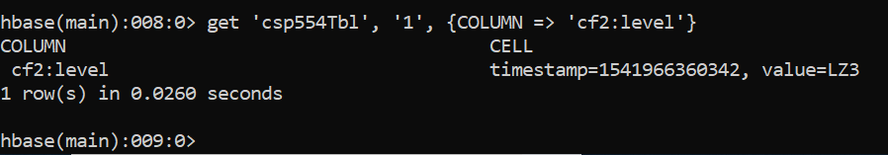

Exercise 4)

Using the above table write command that will get the value associated with row (Row2), column family (cf1) and column/qualifier (name). Provide the command and its result as the output of this exercise.

Command:

get 'csp554Tbl', '2', {COLUMN => 'cf1:name'}

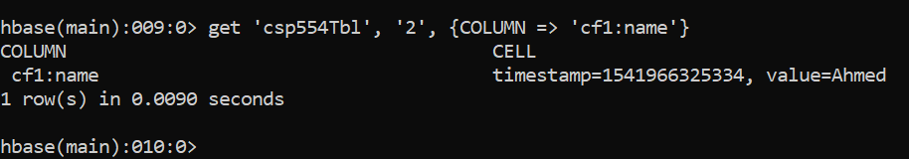

Exercise 5)

Using the above table write a SCAN command that will return information about only one row using the LIMIT modifier. Provide the command and its result as the output of this exercise.

Command:

scan ‘'csp554Tbl', {LIMIT => 1}

